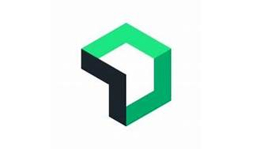

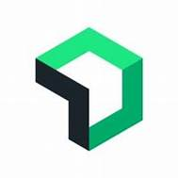

Explore

[**New Relic** is an observability platform that helps you build better software by collecting data from various sources, allowing you to understand your system, analyze data efficiently, and respond to incidents proactively1](https://docs.newrelic.com/docs/new-relic-solutions/get-started/intro-new-relic/). Here are some free resources to learn more about New Relic:

1. [**New Relic University**](https://learn.newrelic.com/): Offers self-paced and live courses, including topics like observability, monitoring, and resolving issues.
2. [**New Relic One Masterclass on Udemy**](https://www.udemy.com/course/new-relic-one-learn-for-beginners/): Learn how to set up New Relic, navigate the interface, and configure settings.
3. [**New Relic Student Edition**](https://newrelic.com/blog/nerd-life/new-relic-student-edition): Provides expanded access to the observability platform for hands-on learning in DevOps and site reliability engineering.
4. [**New Relic Online Webinars and Workshops**](https://newrelic.com/events/online-events): Attend live webinars and workshops to explore New Relic features and best practices.
5. [**New Relic Resources**](https://newrelic.com/resources): Access eBooks, white papers, and datasheets to refine your knowledge[2](https://learn.newrelic.com/).